

**Lab # 05**

**Student Name: Adeel Mustafa**

**Roll Number: BIT-23F-028**

**Section: A**

**Subject: Artificial Intelligence**

**Department: BS Information Technology**

1. Print Numbers with Loops: Write a program that uses a loop to print numbers from 1 to 10.

**Code:**

# for Loop

for i in range(1, 11):

    print(i)

**Output:**

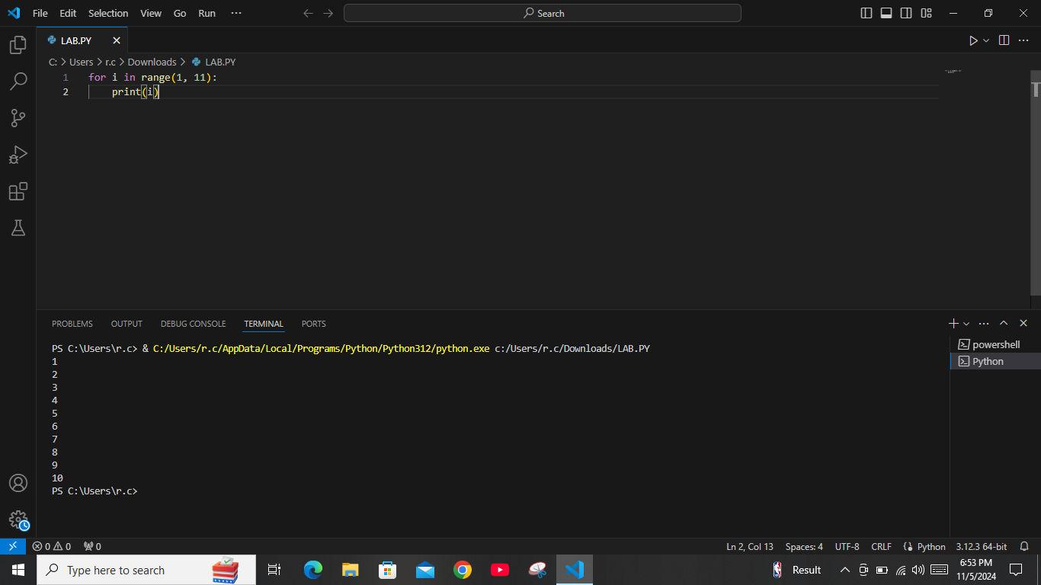

1. Calculate the Sum of Numbers: Write a function that calculates the sum of all numbers up to a given number using a loop.

**Code:**

# Calculate the Sum of Numbers:

def sum_up_to(n):

    total = 0

    for i in range(1, n + 1):

        total += i

    return total

# Example usage

n = 10

print("\n =>  Sum of numbers up to", n, "is:", sum_up_to(n))

**Output:**

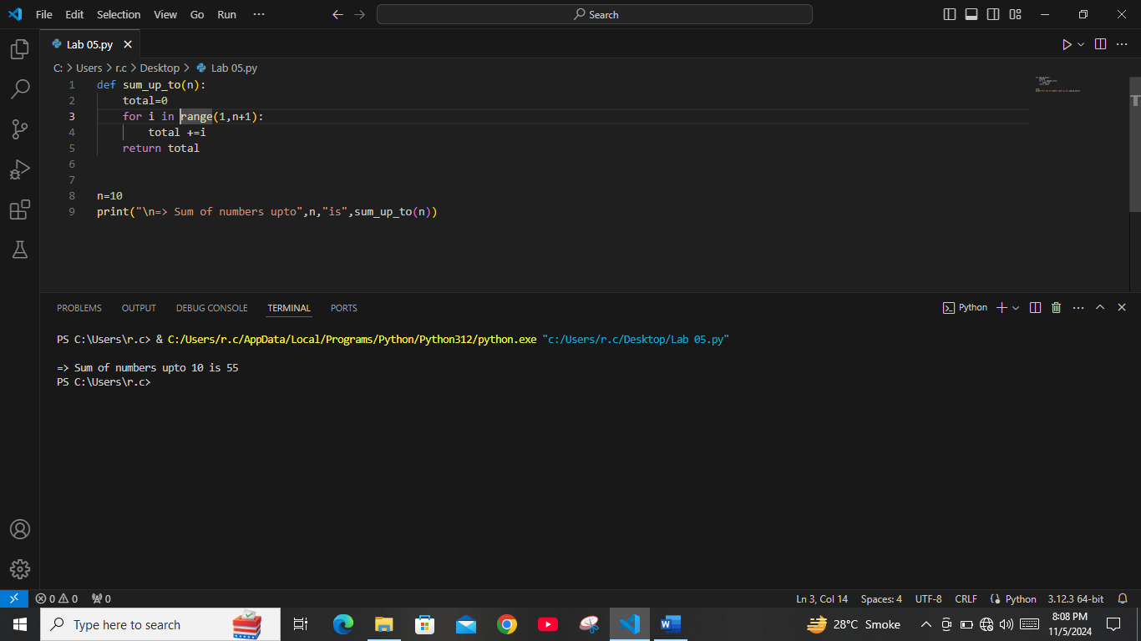

**3:** Display a Star Pattern: Write code using loops and nested loops to create star pattern(discussed previously).

**Code:**# Loop And Nested loop tringle :

r = 6

for i in range(1,r + 1):

    for j in range(1,i + 1):

       print("*", end="")

    print()

print("_________________________________________\n")

# Loop And Nested loop Square:

for i in range(1,6):

    for j in range(1,6):

        print("*", end=" ")

    print()

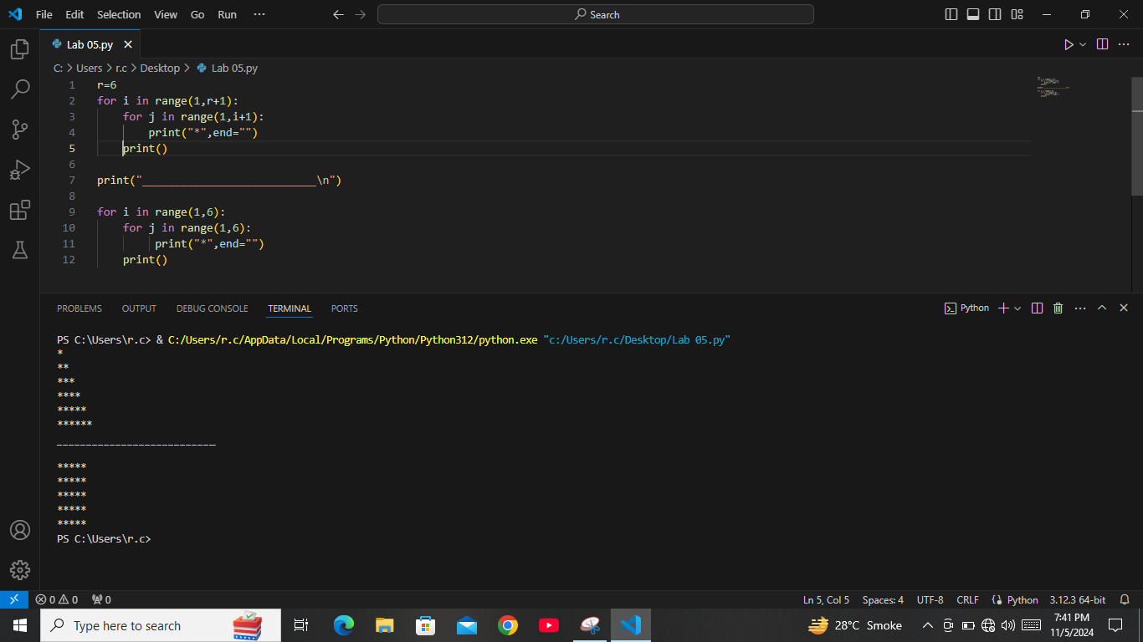**Output:**

**4.** Find Even Numbers in a List: Write a function that takes a list of numbers and prints only the even numbers.

**Code:**

# Find Even Numbers in a List:

def print_even_numbers(numbers):

    # Loop through each number in the list

    for num in numbers:

        # Check if the number is even

        if num % 2 == 0:

            print(num)

# Example usage

print("\n=> Captain! following are Even numbers : \n")

numbers_list = [1, 2, 3, 4, 5, 6, 7, 8, 9, 10]

print_even_numbers(numbers_list)

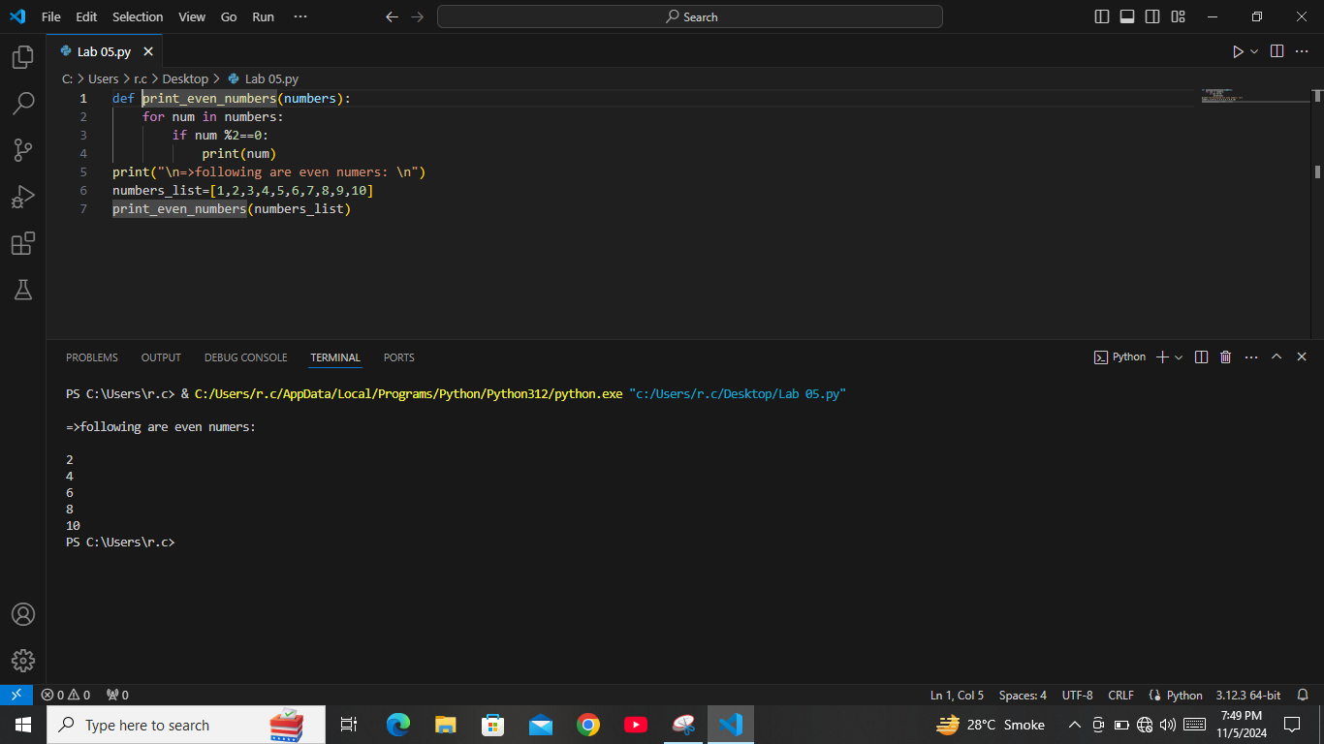**Output:**